LAG Heritage Trails from the Turjak to the Kolpa

The area of LAG (Local Action Group) Heritage trails from the Turjak to the Kolpa, includes 8 municipalities with a total size of 1.191, km² and a population of 38.612 inhabitants. The smallest municipality is Osilnica and the largest municipality Kočevje. A large number of smaller settlements indicates a dispersed settlement.

LAS Heritage trails from the Turjak to the Kolpa is a part of two statistic regions of Slovenia:
- part of the Southeast Region are municipalities: Kočevje, Kostel, Loški Potok, Osilnica, Ribnica and Sodražica;
- part of central Slovenia are municipalities: Dobrepolje and Velike Lašče.

The manager LAG Heritage Trails from the Turjak to the Kolpa:
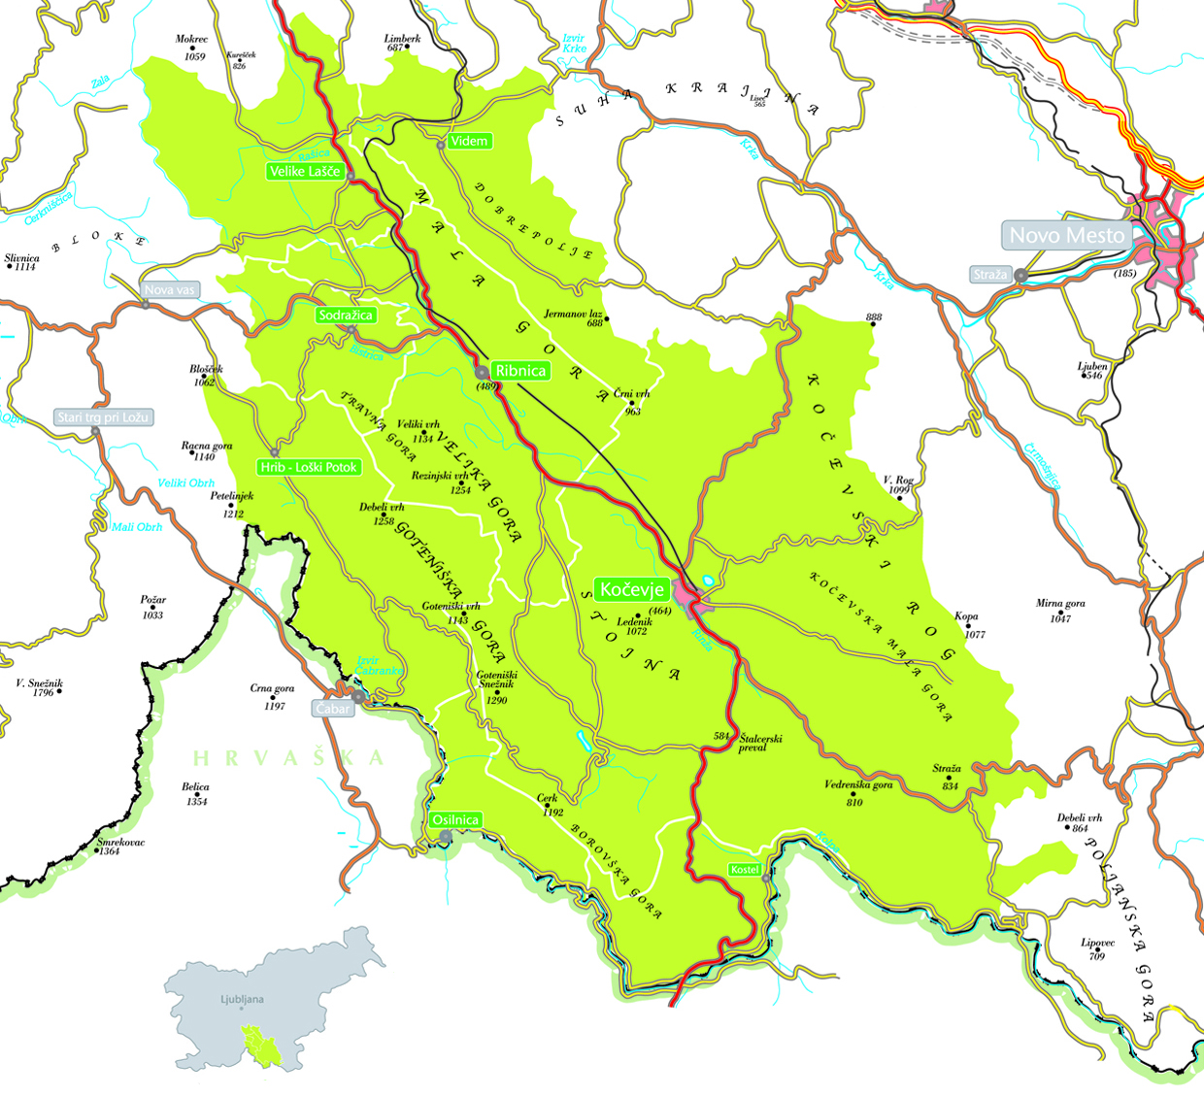
RC Kočevje Ribnica d.o.o.
Trata XIV 6a,
1330 Kočevje
Slovenia
Contact:
Tel: 00386 1 620 84 70
E-mail: info@rc-kocevjeribnica.si
Website: http://www.rc-kocevjeribnica.si

LAG Heritage Trails from the Turjak to the Kolpa
Trata XIV 6a,
1330 Kočevje
Slovenia
Contact:
Tel: 00386 1 620 84 70
E-mail: info@las-ppd.si
Website: http://las-ppd.si

The area of LAS is mainly built of limestones and dolomites, which give a distinctive karst area appearance with numerous sinkholes, chasms, karst caves, karst fields, karst plateau, etc. The climate is continental with long winters and abundance of snowfall and high summer temperatures. More than 78 % of the area is covered by coniferous and deciduous forests (fir, spruce and beech). Natura 2000 covers 67 % of LAG area. Rich flora and fauna. In the forests are found native species of carnivores, such as bears, wolves, wild cats and lynx. The area offers plenty of opportunities for active holidays.

COOPERATION PROJECTS

Areas/Fields of cooperation that we are interested in:
- CULTURAL AND NATURAL HERITAGE
- FORESTRY
- NATURE

Our vision is:

"Creating better living conditions, with development of natural and cultural heritage as well as human capital".

A brief description of Municipalities and what they are known for:

1. Municipality KOČEVJE

Caves of Željne – in the caves of Željne were found archaeological remains from the paleolithic or old stone age.

Artificial lake – creation of artificial lake reaches to year 1978, when the production of coal was stopped. The water from mine stream which was before exhausted and used for coal washing, filled the mining site. Range of lake is settled richly with vegetables and animal types today. Around the lake is made 3 kilometres long natural educated way and leads us to all most typical biotopes (lake, grass, sites and forest). The lake offers an opportunity to fishermen, swimmers, surfers, divers and bird lovers.

2. Municipality KOSTEL

Kostel castle - is a castle on a steep hill almost 200 metres above river Kolpa. It was built between 1247 and 1325 and is the second largest castle complex in Slovenia and the village below it is still inhabited. The original castle was a large tower surrounded by walls and smaller towers built to protect the property of Ortenburg. The castle was first mentioned in documents on 24th June 1336. In 1420 the counts of Celje received the castle under the contract. It was increased by the counts in subsequent years and solidfied with five towers. The castle served as a border fortress and became an important difense point against the Turkish occupation, the castle was burnt due to resistance of Kostel people and Kočevje people. Today, there are articles of different architectural periods visible (Renaissance entrance, stone window frames vaults, loopholes etc.)

Realization of the project World of Kolpa involving both the Slovenian and Croatian municipalities (Kostel, Osilnica, Kočevje, Črnomelj, Delnice, Čabar, Skrad in Brod Moravice) allows the development of high quality active tourism down the upper Kolpa river valley. With the restoring the old school building under this project the tourism development center has been created. This is a multi-purpose center, multimedia space and an information office with permanent and occasional exhibitions, events, workshops, lectures, films books, range of useful products, provision of tourist information.

3. Municipality LOŠKI POTOK

Tabor - is recognizable landscape point, overlooking the beautiful view of the /scenery Loški Potok, was once a fort. Here stand the Church of St. Lenart and St. Barbara - The interior of the church shows a baroque appearance. Concept of the Tabor was defending against the invading Turks in the 16th century.

Retijska uvala (Rhaetian bay) - is one of the outstanding and the most beautiful Slovenian landscape. At the bottom of the valley lies the largest village in Loški Potok called Retje. Underway across the valley are narrow parcels constituting a scenic landscape pattern. During heavy rains in spring and autumn the bay changes in the picturesque lake which surrounds the village, but the houses are set on raised parts of the sinholes, so that the flood does not reach them.

4. Municipality OSILNICA

River Kolpa –Kolpa is a border river between Slovenia and Croatia. Its source is located on the Croatian side, it is 292 km long and it flows into the river Sava. The river offers many opportunities for leisure and recreation - from swimming to boating (kayak, canoe and raft) and fishing.

Mirtoviški potok – the stream is located in the middle of the hilly forest. The spring is surrounded by rocks, which are coated with moss. Mirtoviški potok represents one of the few preserved areas of natural heritage, not only of typical karst landscape, it also contains many rare objects of natural heritage of extraordinary forms of geomorphological, hydrological and biotope features and value.

5. Municipality RIBNICA

The Public Institute Ribnica Handicraft Centre brings together three well-established organizations - the Museum of Ribnica, the Miklova Hiša Gallery and the Museum Shop - as well as a new area, which was likewise developed from the long-standing tradition of Ribnica and its surrounding area: handicrafts (Handicrafts Section). The range of products and services offered by the Institute is extensive and diverse and suitable for different target groups, for both pre-school and school groups, as well as other visitors, researchers, curious individuals and creators.

Ribnica fair - every first Sunday in September the Tourist Association organizes a traditional fair of woodenware and pottery that can offer around 500 stalls with exhibitors and attracts more than 20000 visitors. Ribnica fair has become the largest ethnographic event which has grown into multi-day events, named by people as Ribnica days.

6. Municipality SODRAŽICA

The museum of abandoned agricultural holding in Ravni dol - shows the family life of woodenware and presents a wealth of family life in the last century. In these places people lived for many years from hand-made woodenware products and their sales but they were also engaged in rural work.

“Kadice” - The gorge Kadice, with the influx of Bistrica and with a natural waterfall, is one of the most beautiful sites in municipality Sodražica.

Church at Nova Štifta - the interior of the church is typically baroque with rich ornamentation, three golden altars and wood carvings. The altar and pulpit are among the most beautiful monuments carved art from the second half 17th century. Pilgramage beinnings of Nova Štifta date back to 1583 when on the site of today's templeMary's church or chapel stood.

7. Municipality DOBREPOLJE

Podpeška jama - is the largest underground cave in Dolenjska with long passages and halls long 4,39 kilometres. It is known as the second cave in Europe to have had underground plan made by Janez V. Valvasor in 1687. After the year 1928 the cave had the first biospeleologic laboratory where biologist studied Slovenian karst underground. Beside the stalactite structures in the cave you can also see salamander, bats and other inhabitants of karst underground.

Church off St. Florjan in Ponikve - famous golden baroque altar carved by hand in 1676. The main altar is dedicated to St. Florjan, the patron of firefighters.

Nature conservation and recreational center of social was created in the area of water resources. Here many high-profile events are taking place (Salamijada, Golažijada, Srečanje Podgorcev, Podgorska raja, March with torches to Kamen on Christmas day). In the centre two educational trails can be found which are marked with a number of boards.

8. Municipality VELIKE LAŠČE

Turjak castle - with its Renaissance appearance the castle takes the time in winning battles Turjak lords. In the Dalmatin chapel you can look at paintings from the 15th century, famous Dalmatin passage and the castle dungeon. You can see the knights' hall, a wedding hall and the mighty ox tower. In front of the castle stands the famous old linden tree, Prešeren oak, which is an important dendrological monument.

Homestead of Trubar - by the stream below the settlement of Rašica stands Trubar's Temek mill which consists of memorial house with the mill, Venetian sawmill and outbuilding. In the house you can see the memorial room to review the Trubar work and life with excerpts from his books.

Interest:
- MAS ČESKÝ SEVER – Marek Hartych – hartych@masceskysever.cz
- MAS ŠTERNBERSKO – Jitka Brabcova – brabcova@mas-sternbersko.cz
- MAS KRAJINA SRDCE – maskrajinasrdce@seznam.cz
- MAS SDRZUŽENÍ RŮŽE – z.guthova@seznam.cz

